SUNFIELD CITY SCHOOL (Primary Section)
Week04G4His&GeoP1
History & Geography ___________________________________________________
Name: __________________________________________________________
Cardinal Points
What are Cardinal Points?
The four cardinal directions, or cardinal points, are the four main compass directions: north, south, east, and west, commonly denoted by their initials N, S, E, and W respectively. Relative to north, the directions east, south, and west are at 90 degree intervals in the clockwise direction.
The intermediate direction of every set of intercardinal and cardinal direction is called a secondary intercardinal direction. These eight shortest points in the compass rose shown to the right are:
- West-northwest (WNW)
- North-northwest (NNW)
- North-northeast (NNE)
- East-northeast (ENE)
- East-southeast (ESE)
- South-southeast (SSE)
- South-southwest (SSW)
- West-southwest (WSW)

How to find directions?
We make the use of a compass to find directions. Nowadays we may install o compass on our smartphones also.
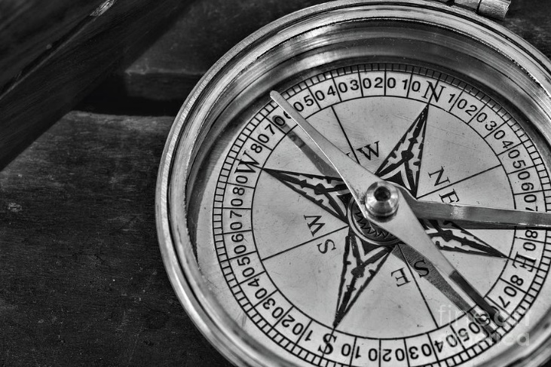
The sun rises in the east and sets in the west.
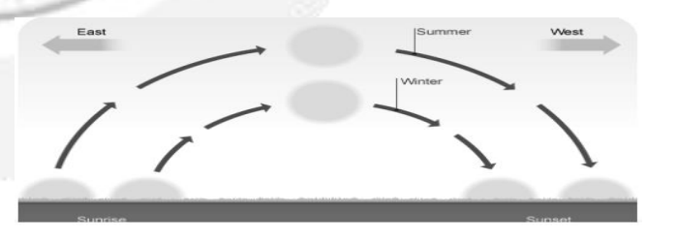
The four cardinal points
The four main cardinal points are north (N), south (S), east (E), west (W)
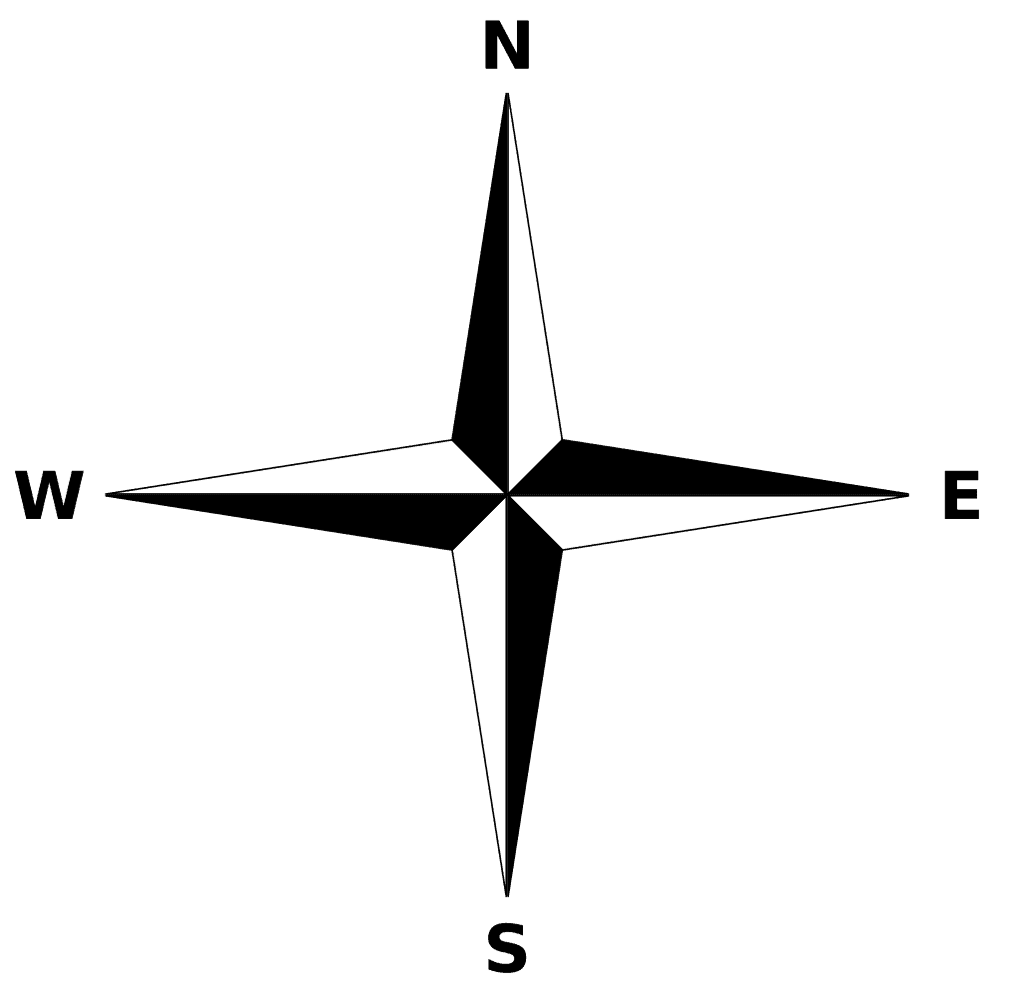
The four intermediate cardinal points are north east (NE) , north west (NW), south east (SE), south west (SW)
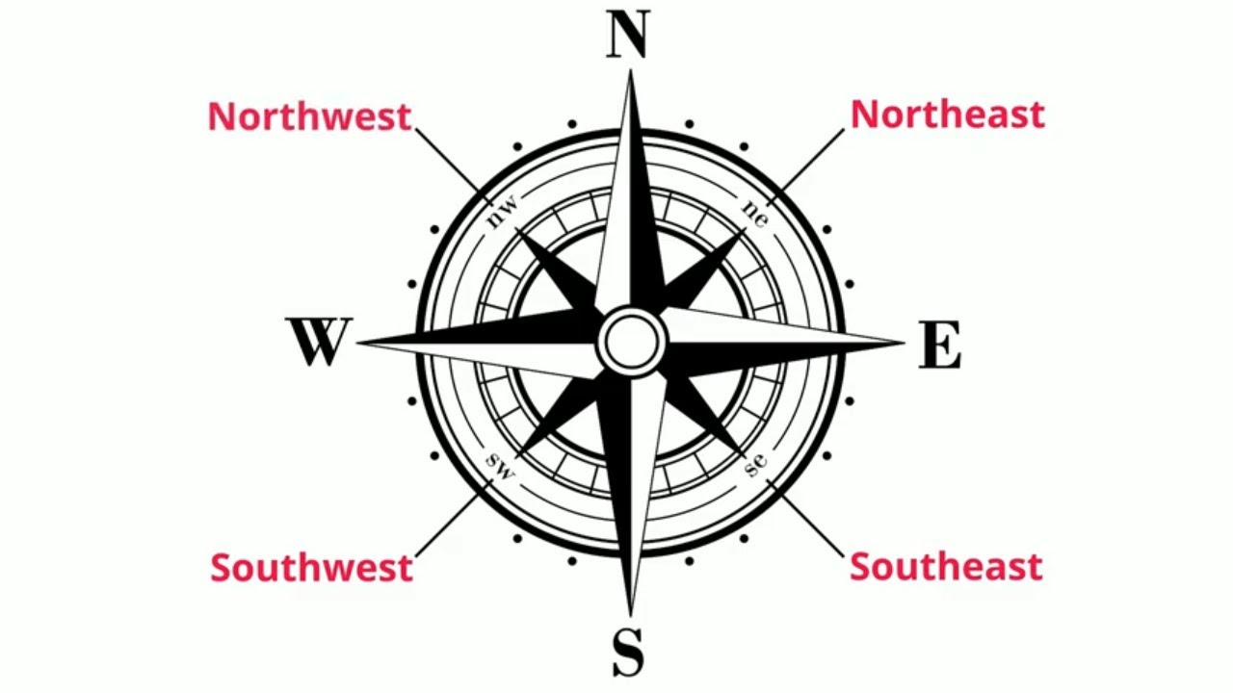

1. Name the four cardinal points and the four intermediate points of a compass.

1. South 2. North East 3. South West 4. East
5. West 6. North West 7. South East 8.North

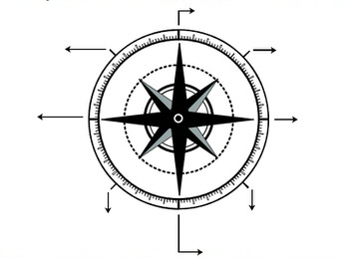

1. In which direction is Blue Bay beach?
____________________________________________________________________________
2. Which important monument is found in the South East?
____________________________________________________________________________
3. Where is Le Morne mountain found and what important fact of the history of Mauritius took place there?
____________________________________________________________________________

SUNFIELD CITY SCHOOL (Primary Section)
Week06G4His&GeoP1
History & Geography ___________________________________________________
Name: __________________________________________________________

1. Complete
a) Alexandra falls is found near which mountain?
____________________________________________________________________________
b) In which district is Mare aux Vacoas reservoir found?
____________________________________________________________________________
c) What beach do we have in the North of Mauritius?
____________________________________________________________________________
d) In which direction can we find Caudan Waterfront?
____________________________________________________________________________
e) Name two inland district in Mauritius?
i) ______________________________________
ii) ______________________________________

2. Complete the diagram below

The picture is showing when the sun is rising, where it is during the day and when it sets.
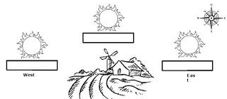

1. Put the appropriate direction in which the sun rises and sets.

2. Put the time of day in the appropriate box. (6 a.m, 6.30 p.m, midnight, noon)

3. On which beach, can we watch a sunset in Mauritius?
____________________________________________________________________________

4. On which beach, can we watch a sunrise in Mauritis?
____________________________________________________________________________

4. Complete the following questions.

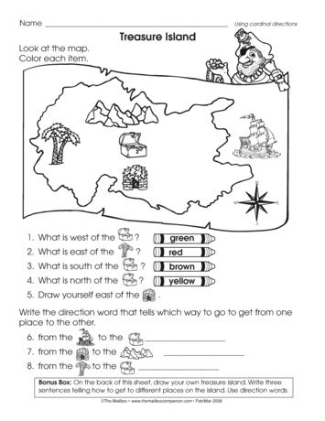
Boat
Mountain range
N
Treasure box
Coconut tree
Hut
1. What is west to the treasure box? Colour it green.
2. What is east of the of the coconut tree? Colour it red
3. What is south of the treasure box? Colour it brown
4. What is north of the treasure box? Colour it yellow

5. Write the direction word that tells which way to go to get from one place to the other.
1. from the boat to the treasure box? ___________________
2. from the hut to the mountain range? ___________________
3. from the coconut tree to the treasure box? ___________________

