SUNFIELD CITY SCHOOL (Primary Section)
Week06G4ScienceP1
Science for ___________________________________________________
Name: __________________________________________________________
What is air?
Air consists of a mixture of gases. These gases consist of tiny particles called atoms and molecules. They are so small that they cannot be seen. Besides gases, air also contains water vapor, dust, pollen, and bacteria. The water vapor in air is the source of rain and snow.
The oxygen in air comes from plants. Through a process called respiration, or breathing, humans and other animals take in oxygen and force out carbon dioxide. Plants take in the carbon dioxide and use it to make food. This is part of the process known as photosynthesis.
The presence of air.
1) Air is present in empty vessels. For example, here if we press the empty bottle continuously, we will feel air on our face. Thus, concluding that air is present in empty vessels as air coming out of the empty bottle.
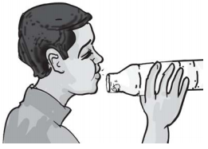

2) Air is present all around us.
We cannot see air but air is present all around us. We can fell air by blowing a paper fan.
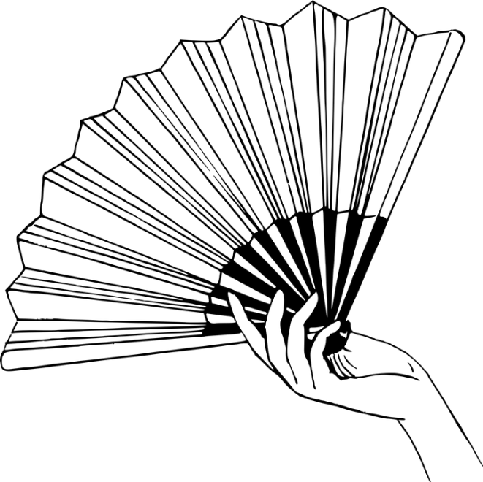
3. Air is present in the soil.
Air is present in the soil. We can denote so when we out a lump of soil in water. After some time, we will see bubbles of air coming out of the soil. Animals living in the soil breathe air from the soil.
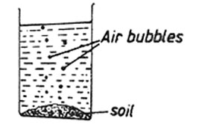
4. Air is present in water.
If we keep a bottle of water on a window sill, after some time we will see bubbles of air coming out of the water, thus demonstrating presence of air in water.
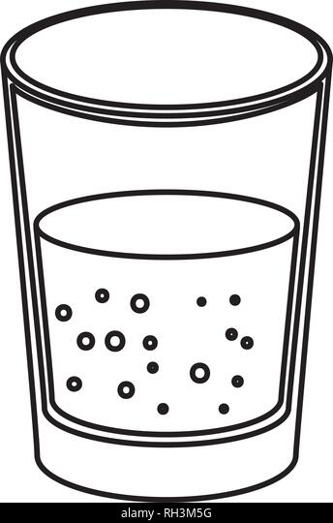
Air bubbles
Properties of air
We cannot see air. Air is colorless, unless air is polluted.
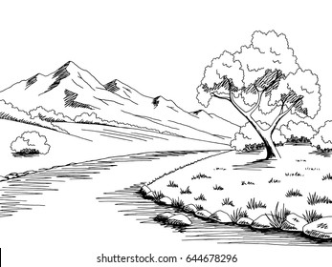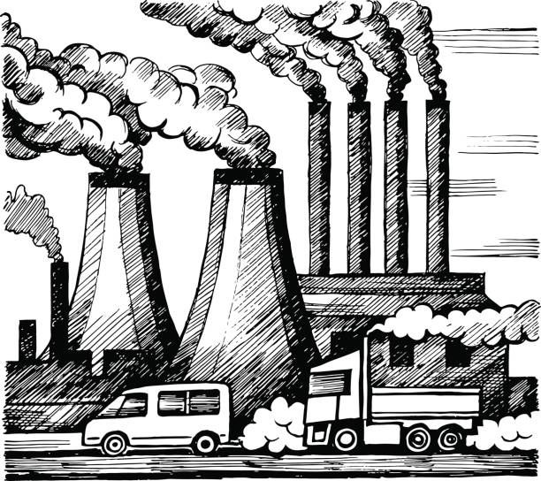
In the first image, everywhere is clean thus we cannot see air. Whereas in the second image, air is polluted.
We cannot taste air, air is tasteless. If we take out our tongue, we won’t be able to taste anything as air is tasteless.

Air is odorless. We cannot smell air. If we can smell air, it implies that air is polluted.
Importance of air.
Air is important for the healthy living of all living things.
Living things need a continuous supply of air.

Animals need air.
Animals need air the same way that human beings need air. Animals obtain air from different sources.
For example:
Ants, earthworms obtain air from the soil
Aquatic animals obtain air from water.
Land animals obtain air from their environment.
Birds obtain air from their environment.
Therefore, animals need plenty of air to stay alive.
Plants need air.
Plants also need air for a healthy living. They breathe through small holes in the leaves called stomata. They take in carbon dioxide and release oxygen.
Plants living in water use air that is dissolved in water.

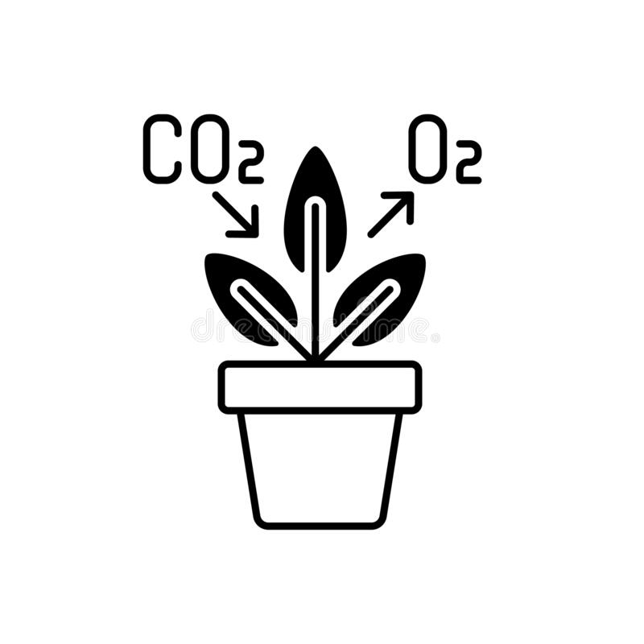
SUNFIELD CITY SCHOOL (Primary Section)
Week04G4ScienceP1
Science for ___________________________________________________
Name: __________________________________________________________
The need of air by non-living things.
Some things are not alive but still need air to function. For example, air is needed for burning.
Even engines of vehicles need air to burn their fuel. Continuous supply of air is needed for burning.
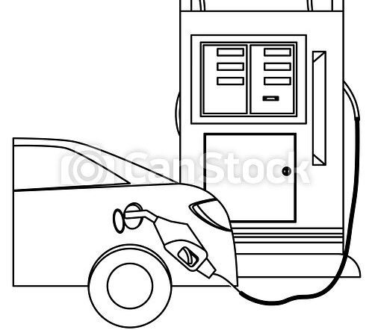
For example, if we light two candles and cover one of them, we will notice that the one which we covered will burn out after some time because it will not get enough supply of air. Whereas the one which is left uncovered will continue to burn as it will get continuous supply of air.
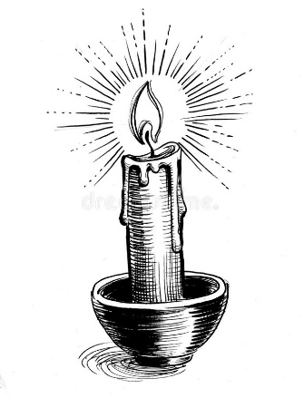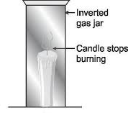
Burning candle
1. Write the correct answer.
a) Air is?
A. bacteria C. living thing
B. a mixture of gases D. non – living thing
b) The water vapor in the air is a source
A. of food C. of rain and snow
B. of fire D. metals
c) Which statement is correct?
A. Pure air is colorless, tasteless and odorless.
B. Pure air is colorful, tasteless and odorless.
C. Pure air is noisy and is not important for living things.
D. Air is not present around us.
d) A plant breathes through its
A. stem C. flower
B. leaf D. roots
e) If a lit candle is covered with a jar, what will happen after sometimes?
A. The jar will burn C. The flame will burn out
B. The flame will continue to burn D. There will be water vapor
f) Which statement is not correct?
A. Babies do not need air while sleeping C. Air is a mixture of gases
B. Humans need air all the time D. Air is present is soil and water
g) Moving air is called
A. rain C. wind
B. sun D. thunder

2. Complete the following.

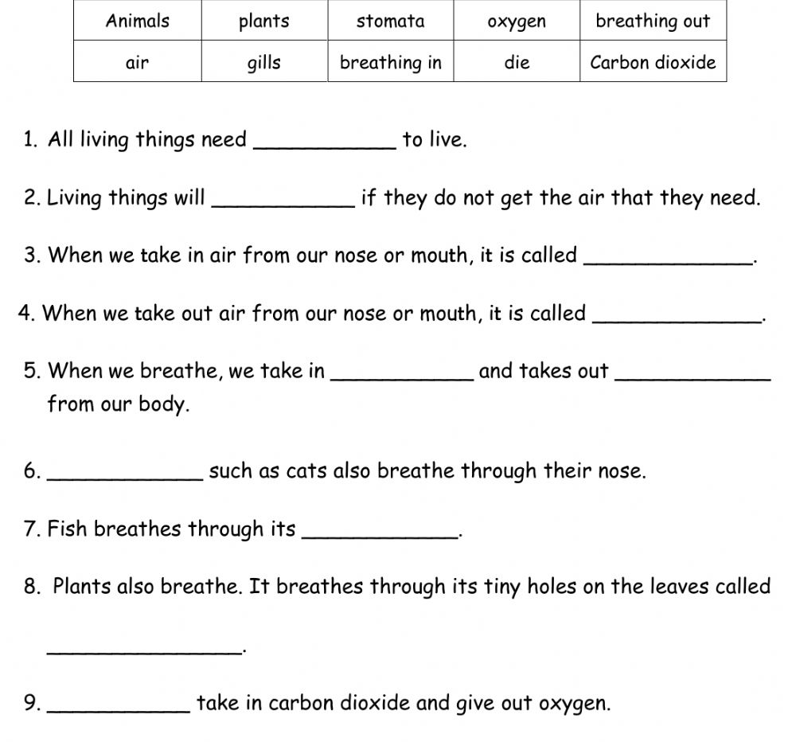

3. Read each statement. Write true or false.
a) Human beings are living things. _______________________________
b) Non – living things can breathe. _______________________________
c) The water, air and sunlight are living things. _______________________________
d) Living things can grow and breathe. _______________________________
e) Air contains smoke, germs and dust. _______________________________

3. Observe the image.

Plant A Plant B
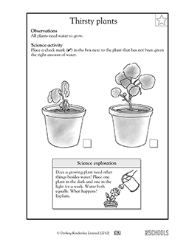
Plant A was in a box with a small hole and small space for 2 days whereas plant B stayed outside.
a) Plant B stayed healthy and grew well, why?
___________________________________________________________________________
b) What happen to plant A
___________________________________________________________________________
c) Explain your answer to (b).
_________________________________________________________________________________________________________________________________________________________
Homework ______________________________________________________
Name: _________________________________________________

d) Describe your observation.
____________________________________________________________________________
_____________________________________________________________________________
____________________________________________________________________________

e) What do plant A and plant B breathe in and breathe out?
_____________________________________________________________________________

4. What can pollute air? Why?
_____________________________________________________________________________
_____________________________________________________________________________
_____________________________________________________________________________
____________________________________________________________________________

