Question 1
Sunfield City School (Primary Section)
Week06Grade1
English (1st term)

Fill in the blanks.
Hello,
My name is
I am a (boy, girl)
I am years old (five / six)
I am in grade ( 1, 2)
I go to school. ( Sunfield City )

Question 2. Color the picture and write down the sentences below.
- The flower is pink. 

- The dog is brown. 

- The carrot is orange. 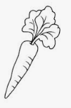

Question 3. Copy the following words 5 times.
  Rainy |   Sunny |   Windy |   Cloudy

