SUNFIELD CITY PRE-PRIMARY AND PRIMARY SCHOOL
LPPS SECTION CLL ENGLISH THEME: PERSONAL HYGIENE
Date: Monday 30th January 2023
Name of child:
Activity 1: To trace and write letter b.
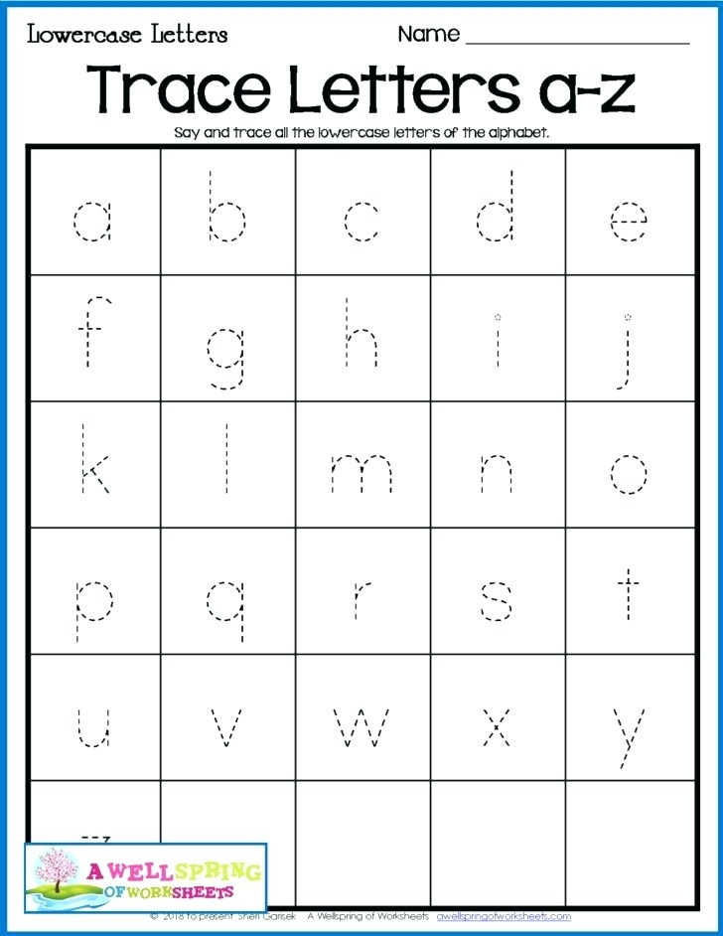

Activity 2: Trace the words and color the pictures.
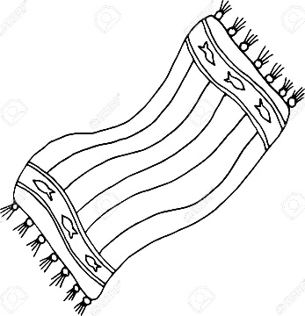




CLL English Theme: Personal Hygiene
Date: Thursday 2nd February 2023
Name of child:
Activity 1: To trace and write letter b.

Activity 2: Matching of same pictures.

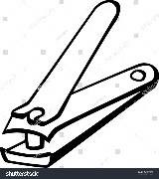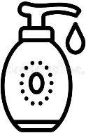
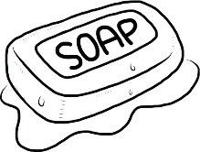
Activity 3: Trace the words and color the pictures.
